CSA1555-Cloud Computing and Big Data Analytics for Education.

Kalikiri Jaswanth Reddy

Reg no:192124019

Lab Activity-Day1

EXP NO 1: CREATE A SIMPLE CLOUD SOFTWARE APPLICATION AND PROVIDE IT AS A SERVICE USING ANY CLOUD SERVICE PROVIDER TO DEMONSTRATE SOFTWARE AS A SERVICE (SAAS).

AIM: To create a simple cloud software application and provide it as a service using any cloud service provider to demonstrate.

PROCEDURE:

IMPLEMENTATION:

STEP1: GOTO ZOHO.COM

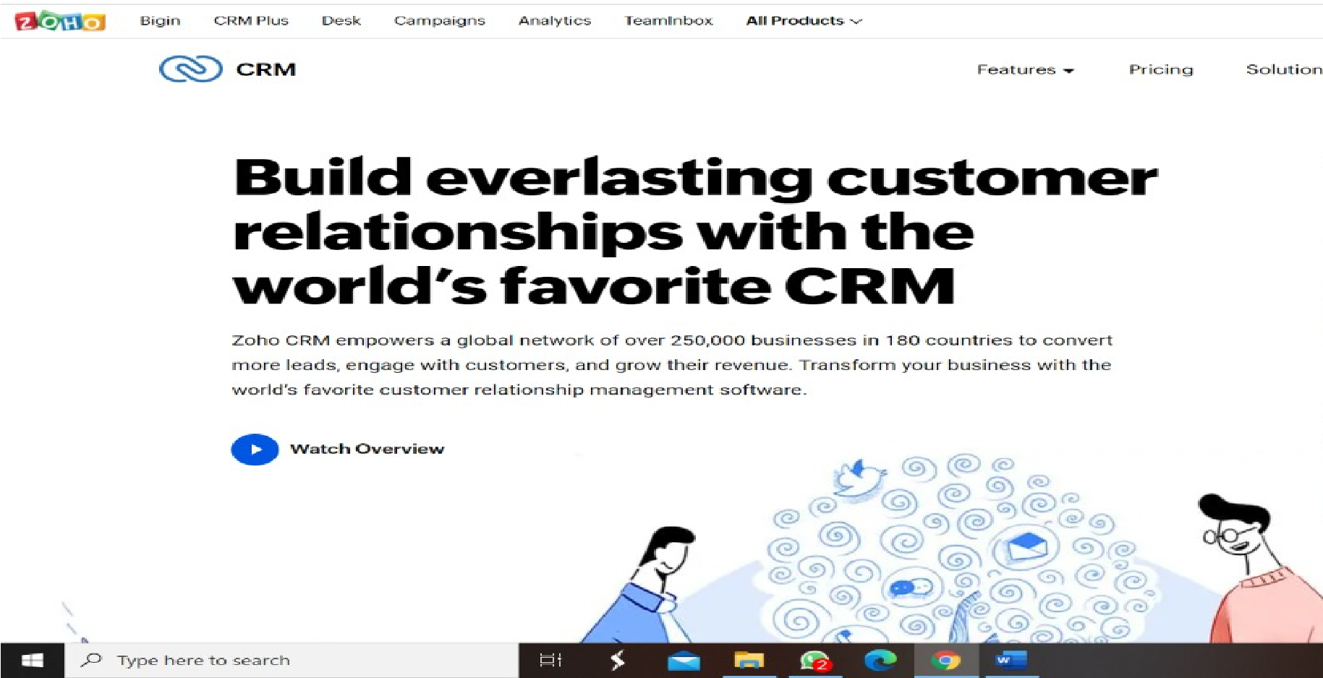

**STEP 2: LOGINTOTHE ZOHO.COM**

 **STEP 3: SELECT ONE APPLICATION**

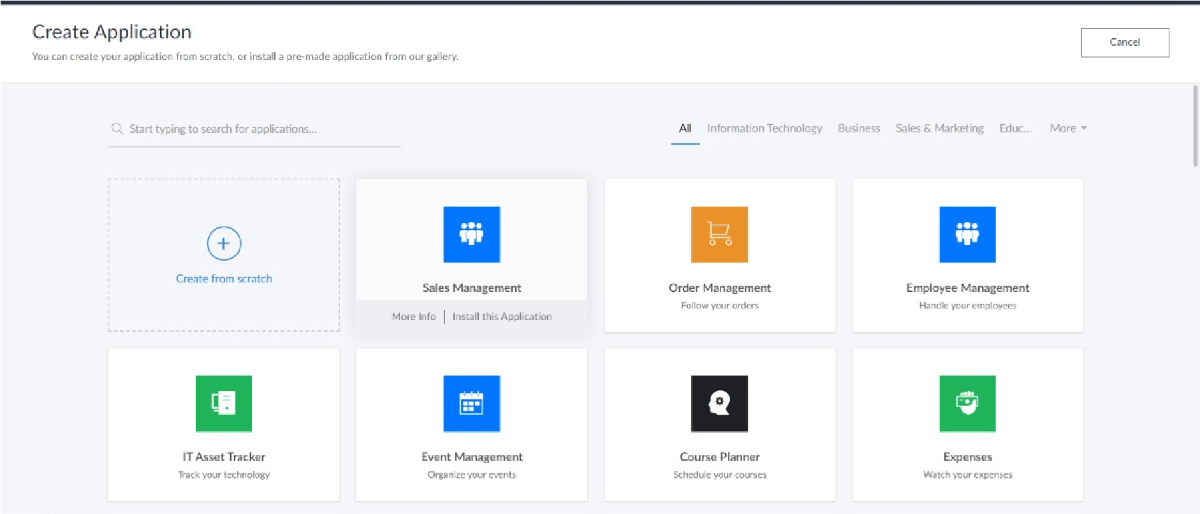 **STEP 4: ENTER APPLICATION NAME**

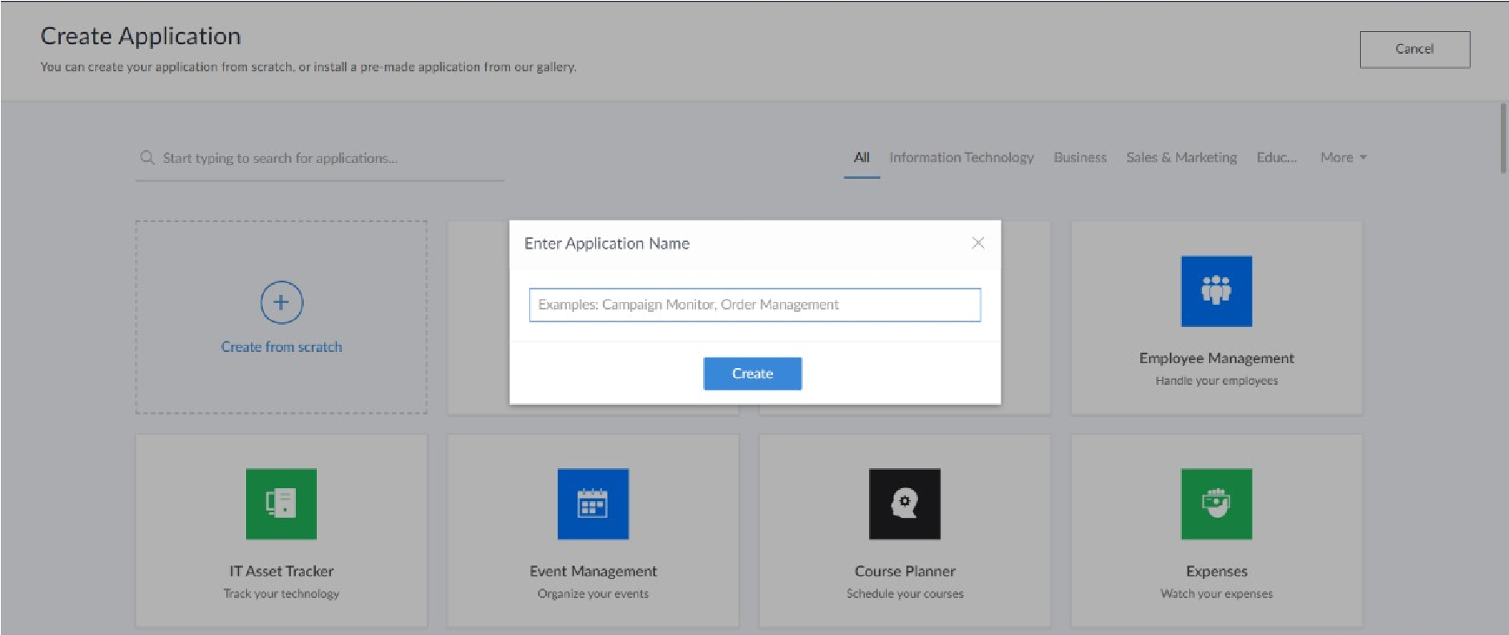 **STEP 5: CREATED NEW APPLICATION**

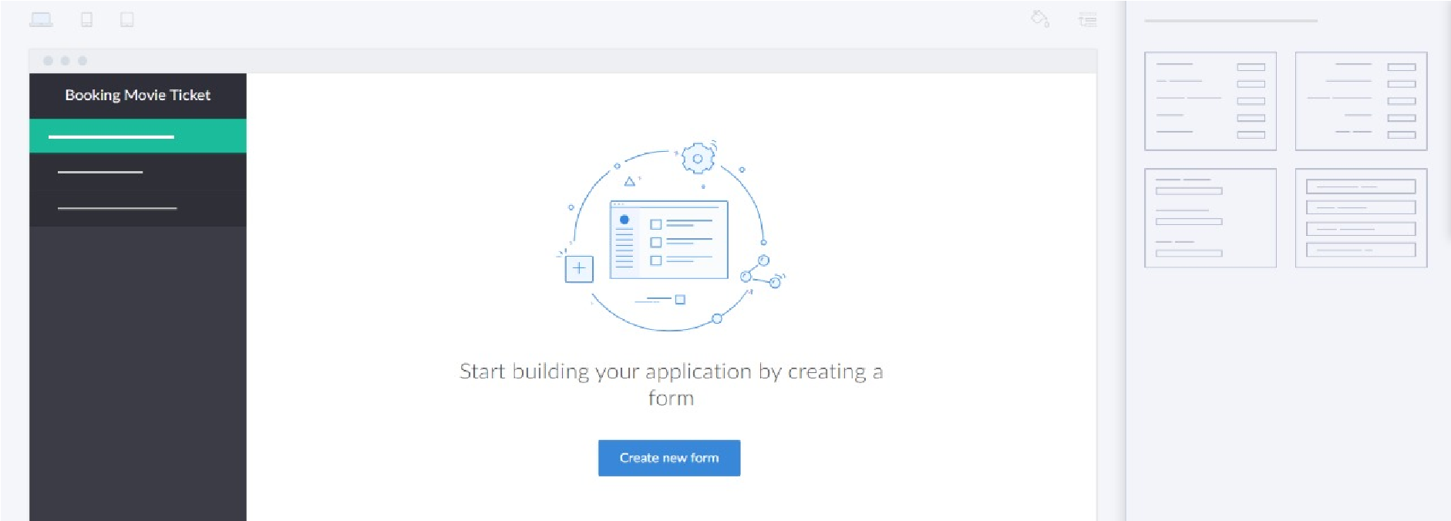 **STEP 6: SELECT ONE FORM**

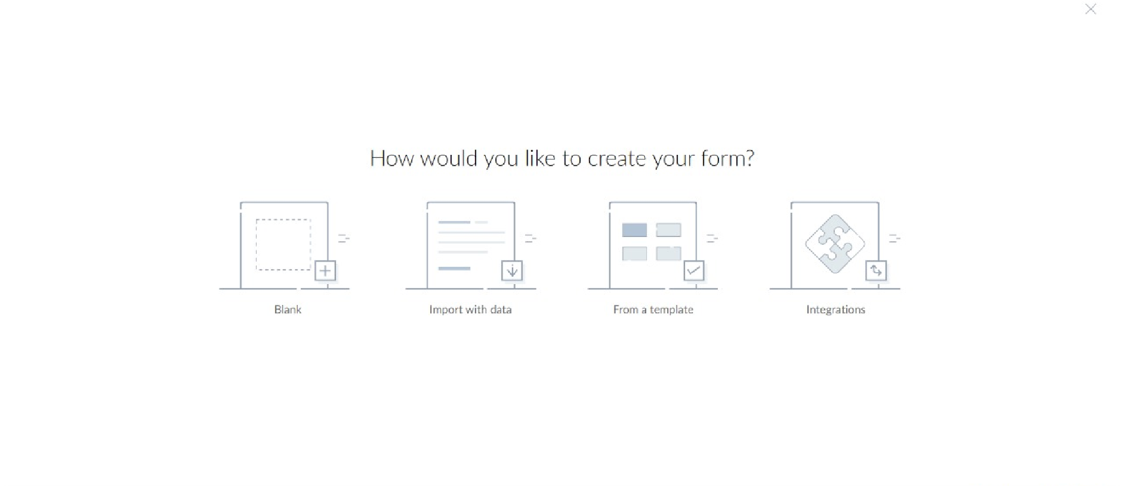 **STEP 7: THE SOFTWARE HASE BEEN CREATED.**

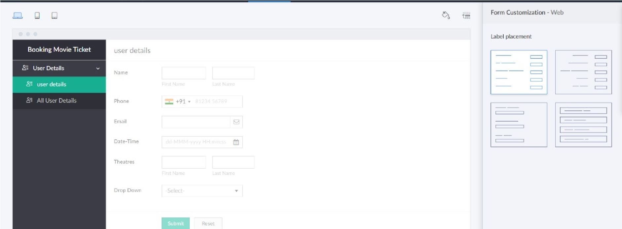

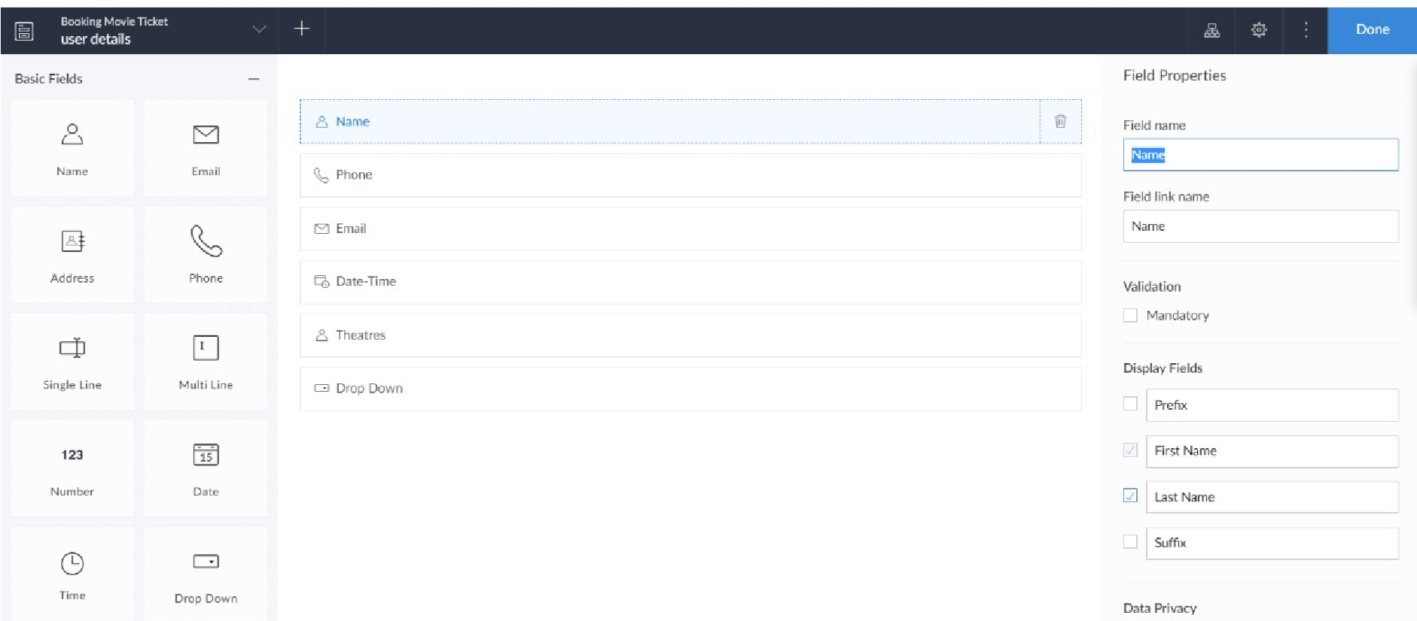

**RESULT: Simple cloud software application and provide it as a service using any cloud service provider to demonstrate software as aservice(SAAS) is created.**